Sand and Dust
Amazingly, the modernization of 20th century Kuwait
required the importation of sand. One would think
that a desert country like Kuwait would be the last
nation on earth to have a shortage of the stuff. But
upon closer inspection, the Arabian Desert is not
covered with sand, but rather a very fine, almost
talcum powder-like dust that lacks the proper silicates
necessary to use in concrete.
So, for modern masonry construction, sand must be
shipped from other regions of the earth. Arabian desert
dust is so fine, in fact, that several times a year heavy
shamal (north) or khamsin winds pick up this desert
powder and carry it several thousand feet into the air,
threatening airline traffic and encouraging even hardy
Kuwaiti shopkeepers to take a “weather holiday.”

Concrete Needs
“When I first got to Kuwait, 95 percent of the food
had to be brought in. So you would think with all that
food being imported, food would be the biggest and
heaviest of all imports. Wrong! Its sand. I thought,
This is crazy. The whole country is sand! But the sand
in Kuwait is not proper for making architectural
concrete, and with their building boom, they needed
more concrete than food.
“In fact, in 2003 one of the biggest complaints we
had, as we were taking up large berth spaces at the port
for bringing in all our equipment, was that there were
ships full of sand having to wait off the Gulf. We had
all these ships stacked up full of sand that needed to be
unloaded so it could be turned into concrete to build
homes.
“That’s why my Kuwaiti friends tell me, ‘The hardest
thing you will ever do in your life as a Kuwaiti is to
build your own home!”’
— Colonel (ret) Randy Williams
MPRI-Kuwait National Guard Development
Program Manager
12
THE LIBERATION OF KUWAIT | THE FORGOTTEN WAR
CHAPTER 1
Piles of rubble were left in the wake of
Saddam's invading troops. Photo courtesy
of Kuwait Ministry of Information.
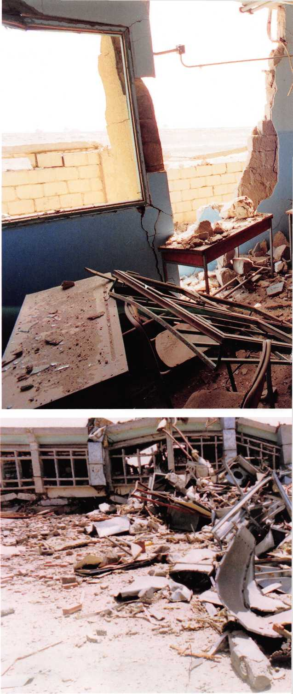

Tank sunk in the desert. Photo
courtesy of Jim Janda. i

Cost of Fresh Water
Kuwait is one of the few nations on earth that has absolutely no sources of fresh, potable
water, though some brackish water can be found in several locations. Considering the
blistering temperatures for much of the year, this absence of renewable water resources
could be lethal. All drinking water in the country must either be shipped in (as it was in
the past) or produced on an industrial scale by mammoth desalinization plants located
strategically on the coasts of the Gulf. It is not an exaggeration to say that a liter of water
costs more than a liter of gasoline in Kuwait.

GOD'S BLESSING: LIFE IN A ROUGH NEIGHBORHOOD
In the 18 th and 19th centuries, Kuwait turned its Arabian Gulf shoreline into a prosperous
port economy. However, after a number of British coastal blockades in the early 20th
century put great hardship on the nation, along with the 1938 discovery of vast oil resources,
Kuwait—with the help of international oil exploration companies—transformed itself.
Making full use of this new capital-generating commodity between 1946 and 1982,
Kuwait invested in a wide array of national infrastructure projects, bringing to the Kuwaiti
people the benefits—and challenges—of rapid modernization and ever-climbing personal
wealth. But just as Kuwaitis began to participate in phenomenal growth and development
and to establish a strong foothold, harsh economic winds again swept over them with the
Kuwait stock market crash of the 1980s.
Undaunted, Kuwait recovered and continued to invest in social services, especially
expanding and modernizing its educational, medical, cultural, and commercial facilities
and oil operations. It also reached out to the world, providing aid and investment in
struggling, underdeveloped regions of Asia and Africa. Kuwait’s methodical and well-
planned economic growth, however, and its extensive investment in the latest and best
technologies, did not go unnoticed—the country would become the prey of the rapacious
Saddam Hussein on August 2, 1990.
CHAPTER 1 | THE FORGOTTEN WAR | THE LIBERATION OF KUWAIT 11
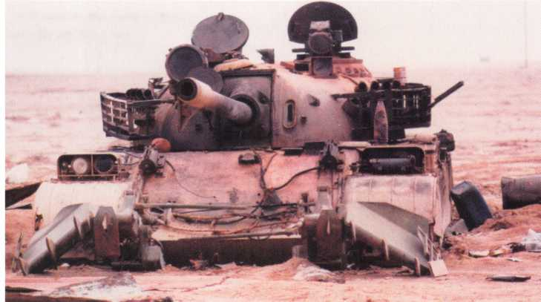
10
THE LIBERATION OF KUWAIT | THE FORGOTTEN WAR | CHAPTER 1
An HH-60H Sea Hawk helicopter
from Helicopter Combat Support
Special Squadron (HCS-4) of Naval
Air Station Norfolk, Virginia, takes
off in the sand for a search and
rescue mission at the start of
Operation Desert Storm. Photo
courtesy of NARA.
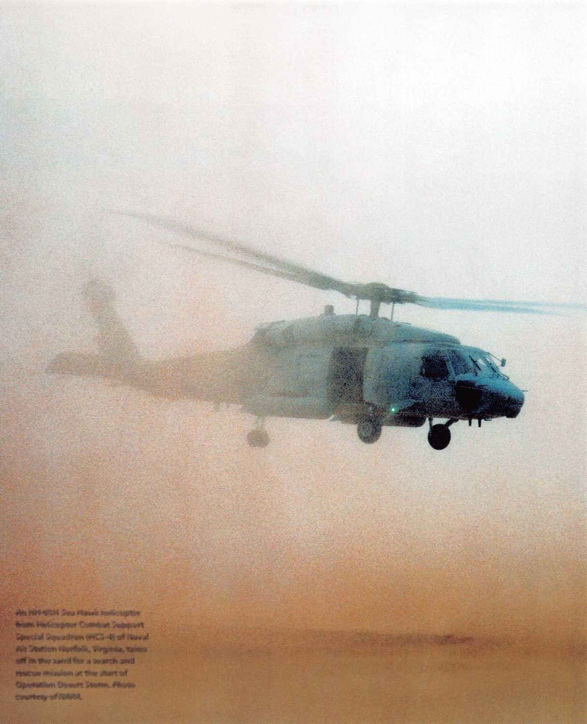
Desert sands of Kuwait.
Photo courtesy of Kuwait
Ministry of Information.
CHAPTER 1 | THE FORGOTTEN WAR | THE LIBERATION OF KUWAIT
9
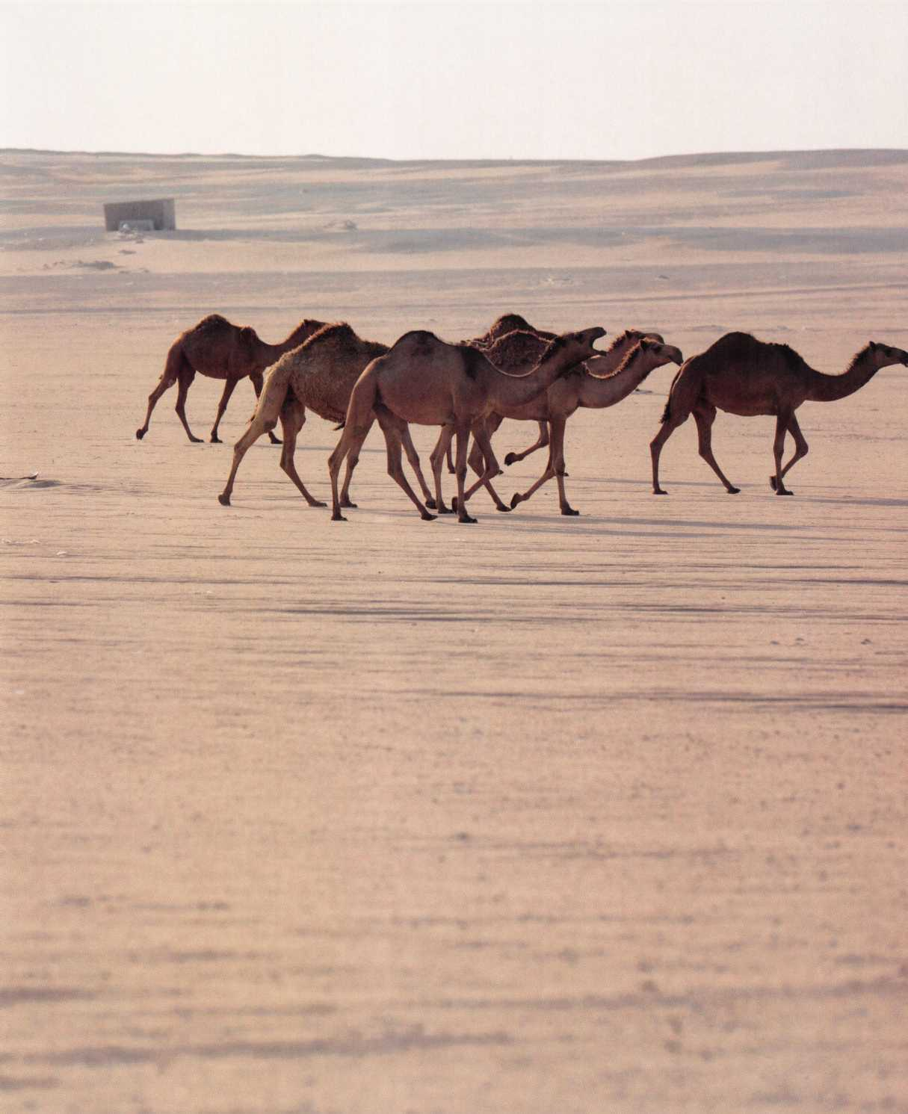

Four Principles
“Four simple principles guide our policy. First, we seek the immediate,
unconditional, and complete withdrawal of all Iraqi forces from Kuwait. Second,
Kuwait’s legitimate government must be restored to replace the puppet regime.
And third, my administration, as has been the case with every [U.S.] president
since Franklin Roosevelt, is committed to the security and stability of the
[Arabian] Gulf. And fourth, I am determined to protect the lives of American
citizens abroad.”
— President George H. W. Bush, August 8, 1990

Origin of the Name Kuwait
Some claim that the name Kuwait originates from the Arabic word akwat, the
plural of kout, which means “small fort (built near water).” Most believe it was
named in the 17th century by local rulers in reference not only to the size of
Kuwait (which is geographically smaller than New Jersey), but also because of
what originally was a migrant, seaside population making a living from the trade
routes, both land and sea.
wounded in October 1920, during the Jahra Battle against insurgent tribes trying to
invade Kuwait City. Later, during an outbreak of smallpox in Kuwait, the hospital
staff saved many who would have otherwise succumbed to the deadly disease.
The American hospital was often referred to as “the original gateway to modern
medicine in Kuwait.” It served the people of Kuwait until the 1960s, when modern
facilities replaced the old structures. Today, the Amricani Cultural Center is located
close to the seaside near Souq Sharq (East) shopping mall.

A TRADITION OF HOSPITALITY AND OPPORTUNITY
Kuwait has always opened its land to foreigners. Millions have worked in Kuwait,
many in high-paying jobs, including tens of thousands of Americans. Kuwait has
sought from its founding to provide opportunities for anyone willing to work hard
and earn success.
Before oil was discovered in Kuwait, this was a land and people disciplined
by circumstance—the country is one of the most arid and hottest continually
inhabited spots on our globe. The people of Kuwait became some of the hardiest,
most resilient, and creative people on earth. They learned quickly to accommodate
a harsh environment, both geographically and geopolitically, developing resilience
and skill in dealing with powerful and potentially threatening neighbors. Americans,
among many others, admired the Kuwaitis’ flexibility and quiet toughness in the
face of hardship.
Such contact with other nations was the result of diplomatic exchange, business
and cultural interaction and cooperation, and, unfortunately, an unavoidable war.
THE LIBERATION OF KUWAIT | THE FORGOTTEN WAR | CHAPTER 1
Kuwaiti student Jasem Al-Habib
volunteered for the U.S. Army during
the Gulf War. Photo courtesy of Kuwait
Ministry of Information.

Embedded with U.S. Ground Forces
Jasem Al-Habib was a young Kuwaiti university student in the United States at the time of the invasion in
1990. “I was going to school at the time,” he recalls, “and it was so difficult to even attend classes, knowing
that your country is being invaded and your family is there and you don’t know what is going on there.
You don’t have any news out of the country.”
But soon Al-Habib knew what he must do: find a way to turn his anxiety into action. “When I heard
the Kuwaiti Embassy was asking Kuwaiti students if any of us wanted to join the U.S. Army, I thought,
what an opportunity! Liberate my own country while serving with the finest military in the world!”
Al-Habib became a volunteer in the U.S. Army, an experience he will always remember. “Anyone who
saw what Saddam Hussein did to my people and our country of Kuwait—making thousands disappear,
setting fire to hundreds of oil wells, and creating one of the most devastating ecological disasters of
modern times—will never forget.”
Al-Habib pleads with this new generation of Kuwaitis and Americans to always remember the atrocities
of a malevolent dictator. “We need to be sure that people don’t take things for granted,” he says. “Saddam
Hussein did some bad stuff. That’s the truth. It’s raw. You can’t forget that. I haven’t.”
formed and strengthened. This is the story of one of the most incredible diplomatic and military successes
in history.

KUWAIT AND AMERICA—HISTORY INTERTWINED
Americans have a place in Kuwait’s history—much more than most people realize. In 1912, the then Amir
of Kuwait, Sheikh Mubarak Al-Sabah, invited American Christian missionaries near Baghdad to come to
Kuwait and establish a hospital. Christian doctors and nurses representing the American Reformed Church
willingly accepted. The result of that provident invitation was the Amricani Hospital, which treated many
CHAPTER 1 | THE FORGOTTEN WAR | THE LIBERATION OF KUWAIT
7
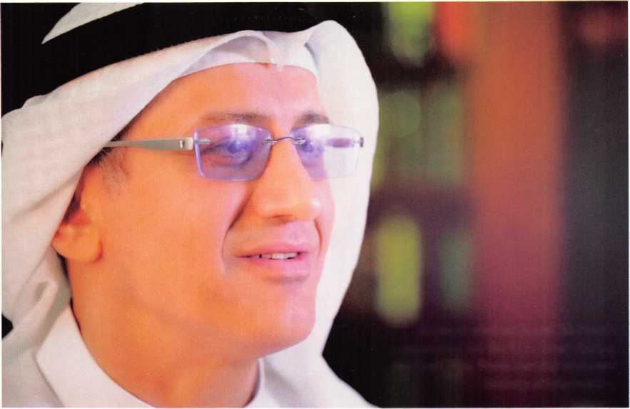

Chapter 2

KUWAIT’S RESPONSE
AND AMERICA’S
COMMITMENT
“We choose our joys and sorrows long before we experience them ”
— Khalil Gibran, Arab philosopher and writer
H
uman history is rarely made by the random
acts of nature and geographic upheaval. In
reality, such things are a mere backdrop
to the true catalyst of history: human choice. These
are the acts, courageous and cowardly, generous and
brutal, which men and women make at key turning
points in history.
On August 2, 1990, wise decisions of the brave and
noble, as well as cruel deeds of the self-serving and
brutal, would change the course of history. Quick
thinking by key members of the Kuwait Amiri Guard,
including young, respected officer Sheikh Fahad
Al-Sabah, ensured that key members of Kuwait’s
leadership escaped to the safety of Saudi Arabia, as
Saddam’s designing web encircled, then smothered,
the country.
Had Saddam captured Kuwait’s Amir, Crown Prince,
Prime Minister, and key Cabinet members, the Iraqi
despot could have eliminated the legitimate leadership
of Kuwait from the start, making it impossible for
the nation to find an approved ruler around which to
rally. These acts of human bravery and selfless sacrifice
at great personal risk were what saved Kuwait as a
sovereign nation.
In Washington, D.C., President Bush watched as
Kuwait was overrun, then pillaged and plundered.
The world turned its eyes to him for leadership.
President Bush was determined from first learning of
Iraq’s invasion to get Iraq to withdraw from Kuwait—
peacefully through diplomacy and economic sanctions,
or forcibly, as a last resort.
In effect, the course of history was determined by one
man’s hard choice to liberate Kuwait. In January 1991,
after all other means had been exhausted, President
Bush signed the National Security Presidential Directive
authorizing the use of force with the United Nations
approval.

THE CHALLENGE: HOWTO MOVE A
MASSIVE ARMY A CONTINENT AWAY
Under siege, Kuwait had two major advantages often
overlooked: determined and skilled leadership, and
influential friends and allies. Also, Saddam had made
the mistake (again, a pivotal choice) of invading a
peaceful neighbor just as the Cold War was winding
down. American forces in Europe were at peak combat
readiness, but preparing to downsize and return home.
In such a changing geopolitical environment, the
United States had the finest military in the world
suddenly freed from European commitments. A logistical
challenge remained, however: how to move a massive
military machine from the forests of Central Europe
to the sands of the Middle East—and do it yesterday.
Land, sea, and air forces had to be deployed from the
United States beginning that first week of August, as
well as Coalition forces from member states who would
contribute military forces. Coordinating and executing
such a massive deployment was a major challenge.
CHAPTER 2 | KUWAIT'S RESPONSE AND AMERICA'S COMMITMENT | THE LIBERATION OF KUWAIT
23

Again, the solution was leadership—along with the
vision and will to choose to right a cruel wrong and ensure
that justice was done, even at a potentially high price. At
the time, experts considered Iraq a formidable foe, on
paper the fourth-largest military on earth, with recent
combat experience in their long war with Iran. Whether
the United States would lead a coalition of nations willing
to fight for Kuwait was anything but certain.

GOVERNMENT IN EXILE
With the assistance and protection of Saudi Arabia,
Kuwait set up a government in exile in Ta’if. There the
Amir of Kuwait and his advisors began a global diplomatic
campaign to counter the many lies issuing from the
Saddam regime. In addition, the citizens of Kuwait were
now scattered and confused. Some were living outside
Kuwait, while others had stayed behind to challenge, or at
least survive, Iraqi occupation.
Kuwait’s exiled government officials had a daunting
task—to take care of their people, both inside and outside
Kuwait, and to rally the world in their defense. Such a
task would take one of the most incredible diplomatic
efforts in history, one that would eventually include a
powerful 35-nation coalition led by the United States.
Even the Soviet Union and China were persuaded to not
block the United States and Kuwait’s actions against Iraq
in the U.N. Security Council. More incredible, perhaps,
was President Bush’s success in persuading Israel to stand
down from fighting, even though Iraqi scud missiles
would consistently attack the Israeli people.

THE ARAB SOLUTION
Not wanting this “squabble” to go beyond the Arab
family, Arab leaders kept searching for al-hal al-Arabi—
an Arab solution. Arab nations never appreciate outside
interference. Arabs by nature are private, preferring to
keep intertribal conflicts within the family. In the days
following his invasion, Saddam was skilled in using that
characteristic as a weapon to forestall any organized
opposition to his occupation. This gave him more time
to entrench in Kuwait, solidify his military and political
control, and begin the elimination of the Kuwaiti people.
It soon became clear that Saddam had no intention of
withdrawing from Kuwait. Still, as long as he appeared
willing to accept some type of Arab solution, Saddam
knew that Arab nations would be reluctant to accept
any kind of international intervention. The Arab
League, particularly, was stymied. While successfully
rallying to produce several resolutions condemning Iraq
and supporting Kuwait’s claims, the Arab League was
unsuccessful in mobilizing any kind of military response
under its mutual defense pact.
League members needed a leader, one they could trust.

SADDAM'S IGNORANCE OF GLOBAL CHANGES
Perhaps the greatest failure on the part of Saddam was
his inability to understand the monumental shift in the
existing world order. The Soviet Union, Iraq’s longtime
ally and weapons supplier, was collapsing. Saddam
had assumed that the USSR would continue to back
him within the U.N. Security Council and stifle any
efforts to condemn his actions. Saddam was blind to
the revolutionary changes taking place: the significantly
improving relations between Washington and Moscow,
and the emerging Russian Republic with new political
goals and objectives in the world. Saddam was so
hopelessly cocooned behind his advisors, the very worst
kind of “yes men,” that he was never aware of the key
geopolitical changes taking place in the world.

BREAKING WITH THE VIETNAM SYNDROME
When the Soviets did not oppose Coalition military
intervention against Iraq, Saddam was distraught.
He believed once more that he had been betrayed,
that conspiracy was the only possible explanation.
Additionally, Saddam did not understand what had
happened within the United States. He believed the
Americans still suffered from what was known as “The
Vietnam Syndrome”—the inability to act militarily in
far-off lands because Americans were still so traumatized
by the Vietnam War.
To make matters worse, Saddam was convinced that
the United States was involved in a nefarious plot to get
rid of him. Consequently, Saddam viewed any attempt


24
THE LIBERATION OF KUWAIT | KUWAIT'S RESPONSE AND AMERICA'S COMMITMENT | CHAPTER 2

Sheikh Saad Al-Abdullah Al-Sabah, Crown
Prince of Kuwait, was forced into exile
during the Iraqi invasion.
Photo courtesy of Kuwait Ministry of
Information.
by the West to bring him to the negotiation table as
suspicious at best.

THE ARAB STREET
Beyond that, Saddam also failed miserably in his
estimation of just how much support for his invasion he
could generate on the “Arab street.” He looked to countries
with a high concentration of ethnic Palestinian refugees,
like Jordan, expecting that if America attacked Iraq, the
Arab world would explode and fight off the “Crusader
invaders.” Saddam was banking on his popular support,
which all his advisors continually assured him he had—a
gambit that turned out to be hopelessly naive.

THIS WILL NOT STAND
When Saddam invaded Kuwait, President Bush and
British Prime Minister Margaret Thatcher both happened
to be in Colorado. They arranged a meeting and quickly
determined that only a coalition of nations could remove
Saddam s military from Kuwait.
The United States and the exiled Kuwaiti government
launched a worldwide diplomatic effort to bring together
a coalition to ensure that international law was enforced
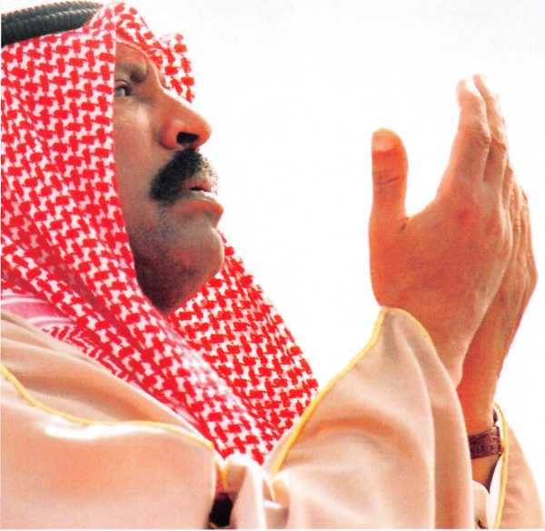
CHAPTER 2 | KUWAIT'S RESPONSE AND AMERICA'S COMMITMENT | THE LIBERATION OF KUWAIT
25
LEFT & ABOVE: Devastation in and around Kuwait City from the invasion of Saddam's troops. Photo courtesy
of Kuwait Ministry of Information.
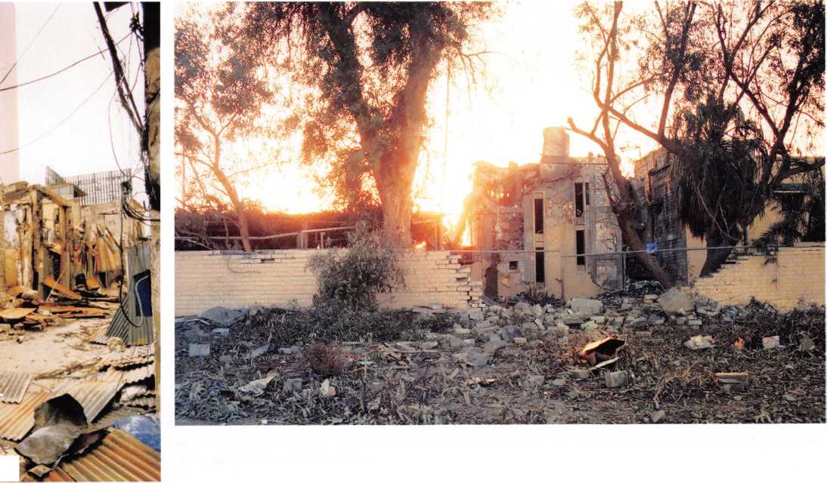

His Highness the Amir of Kuwait Provides a
Quiet Yet Powerful Example to the World
At the time of the Gulf War, Kuwait’s
present Amir, H. H. Sheikh Sabah
Al-Ahmad Al-Jaber Al-Sabah, had been
Kuwait’s top diplomat, the Foreign
Minister, since the 1960s. His skill at
maneuvering sometimes unruly, even
hostile, nations became legendary.
Over such a long and effective career,
Sheikh Sabah became the icon of a
skilled Kuwaiti cadre of diplomats.
Sheikh Sabah knew instinctively where
a tiny nation like Kuwait needed to
place its diplomatic efforts that would
pay the greatest dividends. He was
particularly effective in working with
the Permanent Members of the United Nations’ Security Council. Speaking before
the U.N., Sheikh Sabah said: “Kuwait’s participation in international activities clearly
indicates that our independence and our membership in the U.N. are not ends in
themselves, but are rather a means by which Kuwait can share responsibility in improving
the lives of the people in our country and in other countries.” Through his long career,
the Amir taught and supported peaceful coexistence and a solid diplomatic, cultural, and
commercial cooperation.
Perhaps the greatest challenge in the realm of diplomacy comes with conflict resolution
and in pushing diplomacy to the forefront of public policy. This takes a deft skill in
balancing domestic, as well as foreign, interests. Sheikh Sabah took a lead role in founding
and shaping the Common Ministerial Council for the G.C.C. and the European Union.
This was essential to build the critical ties which make peace and prosperity such a great
blessing to the people.
Sheikh Sabah is well known as a champion for freedom and self-determination and as a
warrior against terrorism. He has stood time and again to demonstrate that Islam is not a
religion of terrorism, but an organization that provides hundreds of millions hope in their
lives and peace in their hearts. But when threatened, as Kuwait was on August 2, 1990,
he became a lion in defense of his people and their rights. His efforts led to the Security
Council’s many resolutions against Iraq for its invasion and helped bring Kuwait to the
forefront of world attention, leading to the passage of several key U.N. Security Council
resolutions.
Later, the effects of the war, sometimes emotional and subtle, helped free and re-orient
the Kuwaiti people and their government, once more shaped by the gentle, yet capable,
hand of Sheikh Sabah.
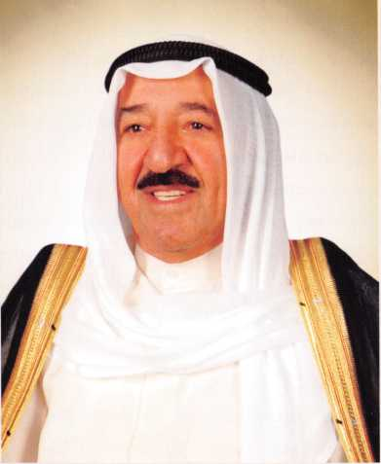
Bombed signal
towers show part of
the damage done to
Kuwait's communication
infrastructure. Photo
courtesy of Kuwait Ministry
of Information.
26
THE LIBERATION OF KUWAIT | KUWAIT'S RESPONSE AND AMERICA'S COMMITMENT | CHAPTER 2


